STRATHMORE SCHOOL - Record of Concern

Please pass this form immediately to the Designated Safeguarding Lead or Deputy DSL.

Pupil’s Full Name: | Pupil’s Class:
Pupil’s Date of Birth: | Pupil’s Age:
Date of Concern: | Time of Concern:
Full name of person taking action:

Signature of person taking action:
Body map completed? (please tick) |  | Y | N
Nature of concern / details of disclosure / other relevant information:
- Please be factual and specific – what are you concerned about? What did you see? What did you hear? Describe the concern as fully as possible. Don’t use your own judgements – state size, colour and location of what you see.

If you have previously had concerns about this pupil, please specify:

ADMIN TO COMPLETE RECEIPT:
Safeguarding Lead Name :
Date and time of concern form handed to SL: |  | Date:  Time:
Action taken:

Added to CPOMS:

Please record the image of the injury on the facial / body map.
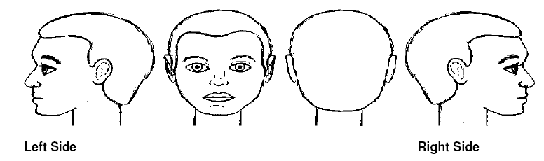

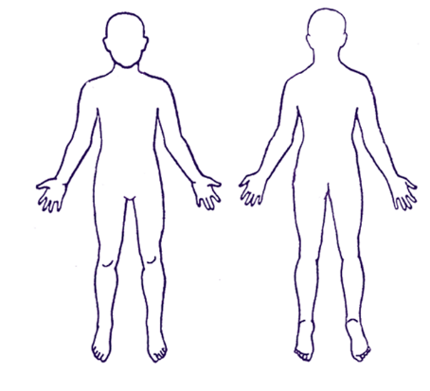
Front
Back
Please factually describe nature of the injury e.g. cut / mark/ lump and the colour.
Specify size by using a reference e.g. dark purple mark about 3 cm across, circular in shape.

