Blank’s Levels of Questioning

- Based on research conducted by Blank, Rose and Berlin with year one students to analyse levels of comprehension required for the classroom
- The four levels are categorised according to complexity from concrete to abstract
- Enables adults to direct questions at the child’s level of understanding thereby ensuring success for the child
- Able to expose students to questions at the next level to stimulate development of comprehension skills
- At the beginning of year 1 children need to understand language from all 4 levels to understand all classroom language
- Questions require both receptive and expressive language

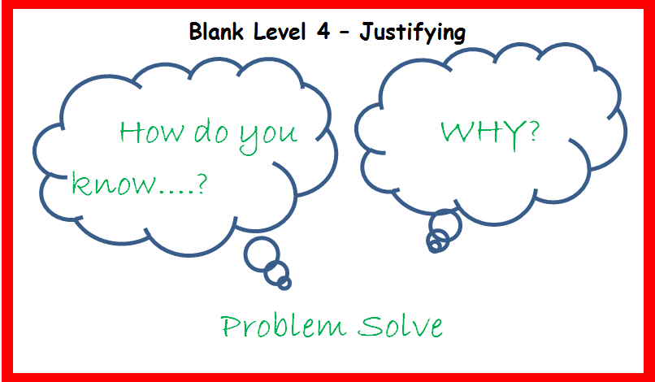
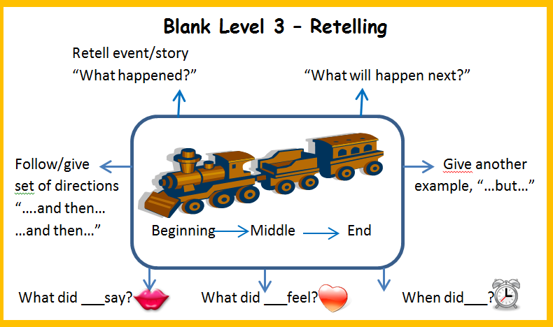
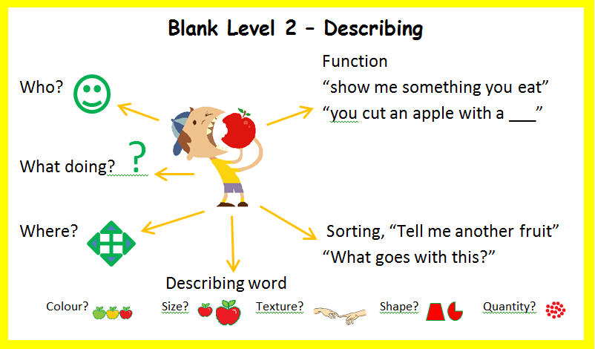
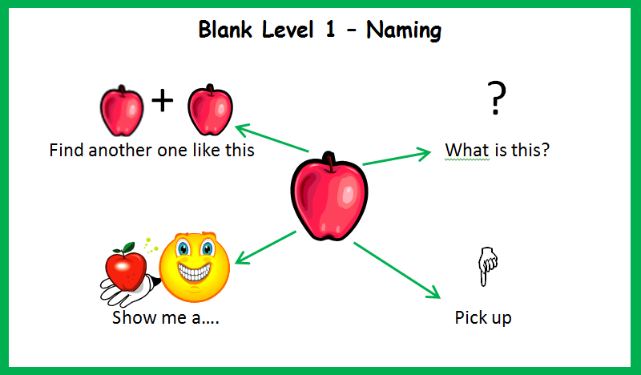
Concrete
Abstract

